|  |
| --- |
| ENERGY ANALYSIS |
|  |

|  |  |
| --- | --- |
| August 4, 2019 | PROJECT #1 |

**TEAM DAGGER  
George Bigham, Dawn Brenner, Adam Pritchett**

ENERGY ANALYSIS

PROJECT #1

## INTRODUCTION

After selecting “Energy” as the topic for our project, our team found our primary data source, Global Power Plant Database. This dataset included additional kilowatts generated each year per country through the commissioning of new power plants, thus provided the maximum energy generation capability of each country. Generated energy is always consumed; therefore, a country’s energy generation and consumption are the same. After viewing the data, we chose some interesting questions and formed our hypothesis.

*Hypothesis: A country’s energy consumption and use of “green” energy increases with that country’s prosperity.”*

We added the following additional data sources to answer our questions:

* Human Development Index (HDI), United Nations Human Development Data: A countries prosperity is measured in terms of life expectancy, education, and standard of living with the Human Development Index (HDI).
* Population, World Bank Population Data: Since a country’s energy consumption typically increases with population, our data was more informative dividing it by the population to get generation/consumption per capita.
* Consumption: Since our capacity data did not include baseline capacity, identify capacity decreases from decommissioned plants, nor consider that power plants are not always operating at full capacity; we imported an additional data source with energy consumption per country.

## SUMMARY

After importing, cleaning, merging, and analyzing our datasets, we were able to answer the questions discussed below. Ultimately, we rejected our hypothesis.

*Findings: A country’s energy consumption and use of “green” energy does not always increase with that country’s prosperity.*

## QUESTION #1

## Is energy consumption increasing or decreasing over time?

Energy consumption/generation is increasing over time. As the world’s population increases, more energy is needed to meet its power needs. The animated heat map (see our Git Hub repository) shows new power plants added continually to meet rising energy needs each year.

With concerns about climate change, efforts have been made to conserve energy. We divided energy generation by the population to see if energy is increasing or decreasing without effects of population growth. The Figure 2.1 below shows energy generated per capita globally and regionally from 1965 to 2018. Figure 2.2 below shows best fit line for energy generated per capita. The slope of the best fit line listed in the legend shows that energy is increasing globally and in all regions except North America.

From Figure 2.1, it is interesting how much energy per capita is consumed in North America compared to all other regions. Also interesting is the Commonwealth of Independent States (CIS) plot line. (The CIS region is the former Soviet Union.) This line indicates that energy use is likely dependent upon other factors (the steep dive occurred around the disbanding of the Soviet Union).

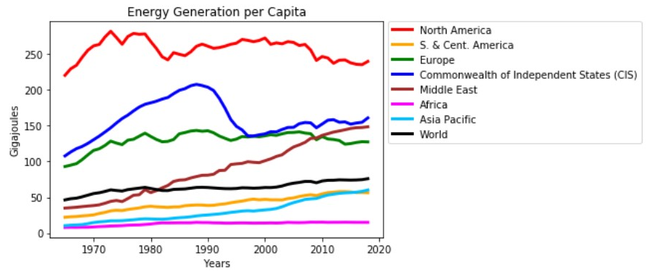Figure 1.1: Regional Energy Generation per Capita

Figure 1.2: Best Fit Lines of Regional Energy Generation per Capita 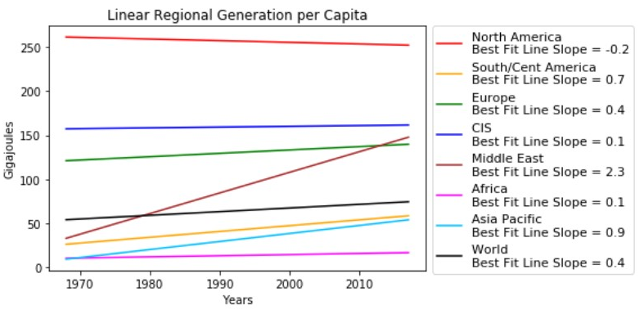

## QUESTION #2

## Is energy consumption related to a country’s prosperity?

On a global scale, we calculated energy capacity to be weakly correlated with HDI (our prosperity index). However, there is a strong correlation between energy capacity and HDI with many individual countries. It would be interesting to investigate those countries to determine causation. Figure 2.1 is a bubble plot of all country’s HDIs versus their total capacity added between 1989 and 2017. The size of the bubble indicates the country’s population in 2017. (An animated version is available on our Git Hub repository - animated_gapminder.gif.) From the figure, you see values across the board including many high-HDI countries with very low energy capacity. A country cannot consume what it doesn’t generate. Therefore, we know that energy consumption does not increase with prosperity.

Figure 2.1: Energy Capacity per Country vs HDI

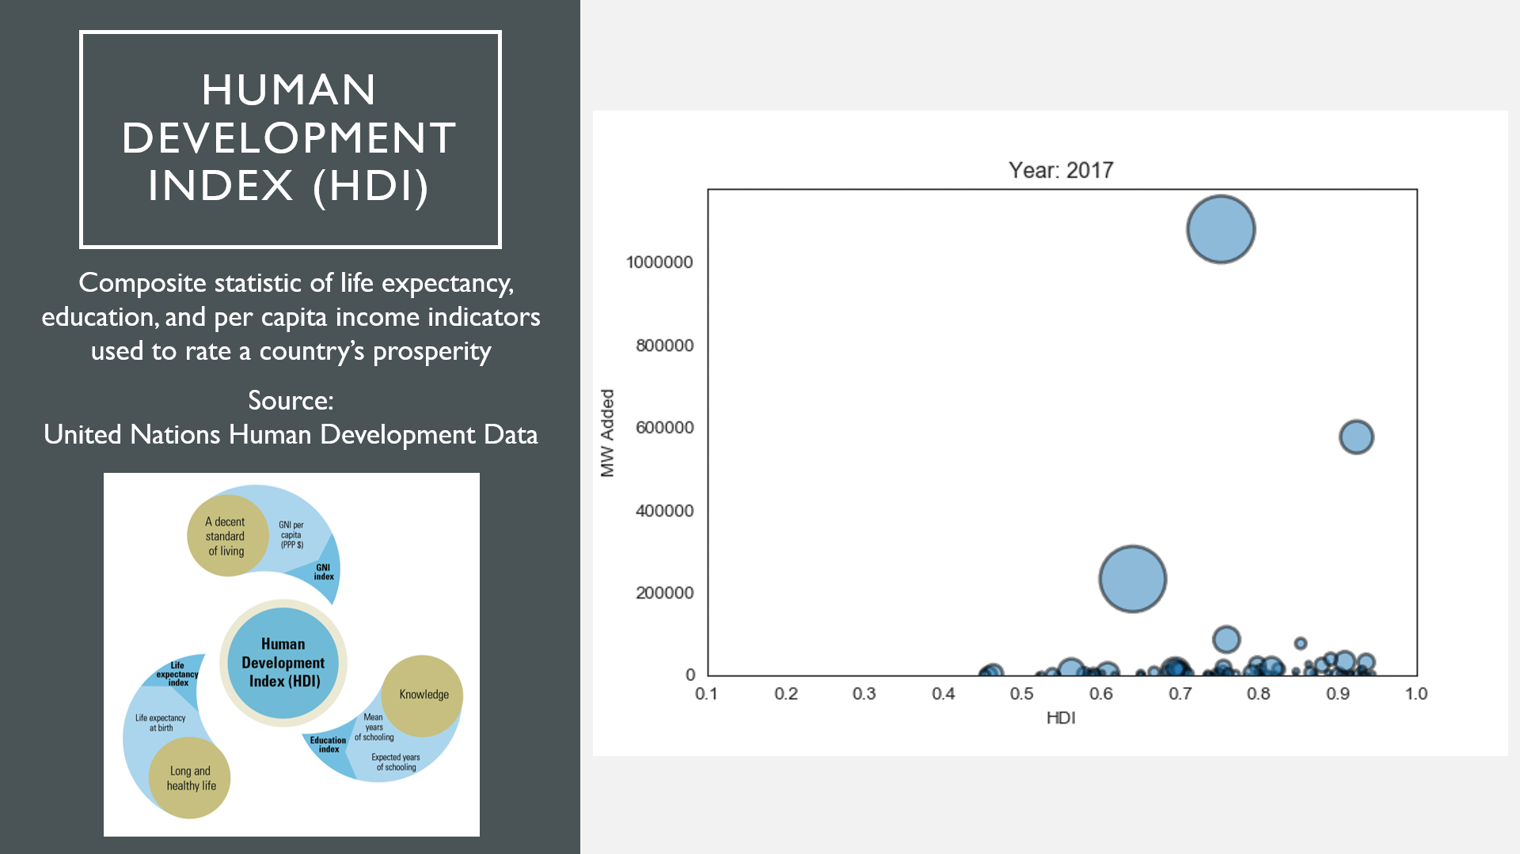

## QUESTION #3

**Do more prosperous areas use more “green” energy.**

We hypothesized that more prosperous areas would have the education and resources to prioritize “green” energy sources to increase energy generation capacity. Figure 3.1 below shows the types of fuel sources used to generate the energy consumed by geographical regions in 2018. Although some environmentalists argue that hydro power is not “green,” we are included it as a green source of fuel because it does not consume non-renewable resources nor cause air pollution. Figure 3.2 shows the fuel sources of added power plants in 2017 and indicates green fuel sources are prioritized in only the Americas. Figure 3.3 below shows the percent of energy generated from green versus non green fuel sources. South and Central America shines in this figure as a region that most prioritizes green energy. Comparing these figures with Figure 3.4 demonstrates that the use of green energy is not related to prosperity.

Figure 3.1: 2018 Regional Energy Consumption by Fuel Type

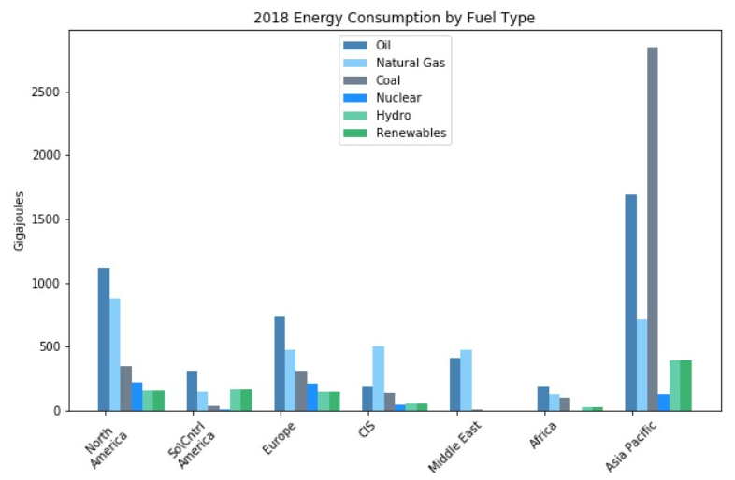

Figure 3.2: Regional Capacity Added in 2017 per Fuel Source

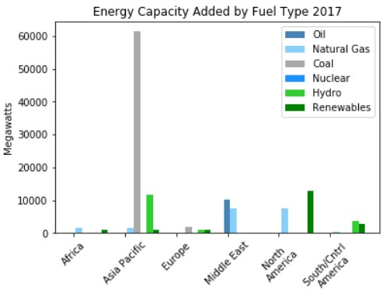

Figure 3.3: Percent of Total “Green” vs “Non-Green” Regional Energy Generated

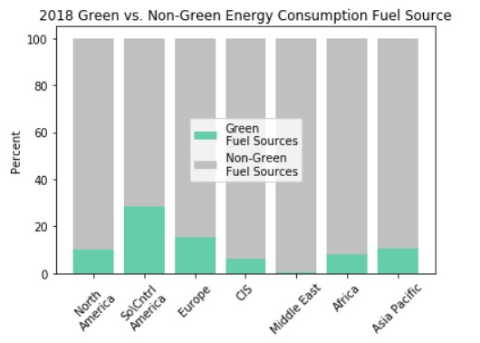

Figure 3.4: Global Map of HDI

## 

## CONCLUSION

We were surprised that an area’s energy consumption and use of “green” energy did not always correlate with its prosperity. It seems like an area with more wealth would use more energy. Further, it seems like areas with high wealth and education would spend more to be more environmentally responsible towards non-renewable resources and air pollution. We found both to not always be true as there are other unidentified factors involved. Additional time should be spent identifying and analyzing other possible factors.